Create a class Box that uses a parameterized method to initialize the dimensions of a box.(dimensions are width, height, depth of double type). The class should have a method that can return volume. Obtain an object and print the corresponding volume in main() function.
class Box {
double width;
double height;
double depth;
Box(double w, double h, double d) {
width = w;
height = h;
depth = d;
}
double volume() {
return width * height * depth;
}
}

class BoxDemo {
public static void main(String args[]) {
Box ss = new Box(10, 20, 15);

double vol;

vol = ss.volume();
System.out.println("Volume is " + vol);
}
}

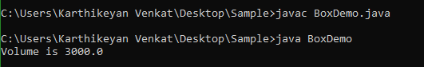
Create a new class called “Calculator” which contains the following:

2.1. A static method called powerInt(int num1,int num2) that accepts two integers and returns num1 to the power of num2 (num1 power num2).

class Calci
{
static double powerInt(int num1,int num2)
{
return Math.pow(num1,num2);
}
}

public class Calculator
{
public static void main(String args[])
{
System.out.println(Calci.powerInt(10,3));
}
}

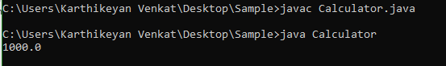

2.2. A static method called powerDouble(double num1,int num2) that accepts one double and one integer and returns num1 to the power of num2 (num1 power num2).

class Calci
{
static double powerDouble(double num1,int num2)
{
return Math.pow(num1,num2);
}
}

public class Calculator
{
public static void main(String args[])
{
System.out.println(Calci.powerDouble(10.23,3));
}
}

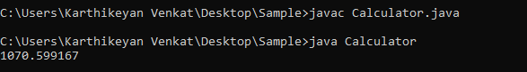

2.3. Call your method from another class without instantiating the class (i.e. call it like Calculator.powerInt(12,10) since your methods are defined to be static)
Hint: Use Math.pow(double,double) to calculate the power.

class Calci
{
static double power1;
static double powerDouble(double num1,double num2)
{
power1=Math.pow(num1,num2);
return power1;
}
}

class Calculator
{
public static void main(String args[])
{
double p=Calci.powerDouble(10,12);
System.out.println("The result is: "+p);
}
}

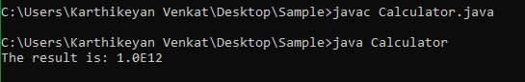

Design a class that can be used by a health care professional to keep track of a patient’s vital statistics. Here’s what the class should do:
3.1. Construct a class called Patient
3.2. Store a String name for the patient
3.3. Store weight and height for patient as doubles
3.4. Construct a new patient using these values
3.5. Write a method called BMI which returns the patient’s BMI as a double. BMI can be calculated as BMI = ( Weight in Pounds / ( Height in inches x Height in inches ) ) x 703
3.6. Next, construct a class called “Patients” and create a main method. Create a Patient object and assign some height and weight to that object. Display the BMI of that patient.
class Patient
{
String name;
double height,weight;
Patient(double h,double w)
{
height=h;
weight=w;
}
double BMI()
{
return((weight/(height*height))*703);
}
}
class Patients
{
public static void main(String args[])
{
Patient p=new Patient(19,180);
System.out.println("BMI OF IT="+p.BMI());
}
}

